Serverless Development 101

**Module 04 – Developing a Web Application using Serverless Computing**

1/10/2019 Developed by Kevin Wang

1/10/2019 Checked by Clark Jason Ngo

1/10/2019 Tested by Tuan Khai and Minh Truong

2/16/2019 Revised by Sam Chung

4/20/2020 Updated by Apiwat Chuaphan

Center for Information Assurance (CIAE) @City University of Seattle (CityU)

  

**Learning Outcomes**

* Learn how to serve static content (HTML, CSS, & JavaScript) with Lambda.

Note: with AWS, you have different options to serve static content to your end users by using an EC2 or Lightsail instance with Apache HTTP Server or Nginx, S3, and so forth. In this module, we will introduce an alternative option that is to use a Lambda function in order to build our own web server and serve the static content to users.

**Develop a Web application using an AWS Lambda function**

1. Open the VSCode and open the “myproject” project folder that we created in the previous module.
2. Open the ‘get-index.js’ file under the functions folder.

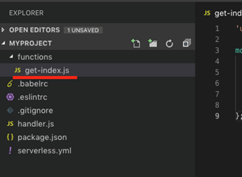 

1. Open <https://bit.ly/2XMYffc>  and compare it with ‘get-index.js’ file.  
   A new “getHtml” function is added as well as the modification of the main lambda function.

**Current One**

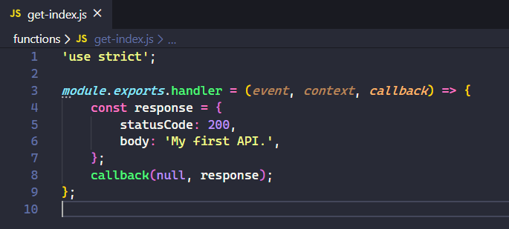  
**New One**  
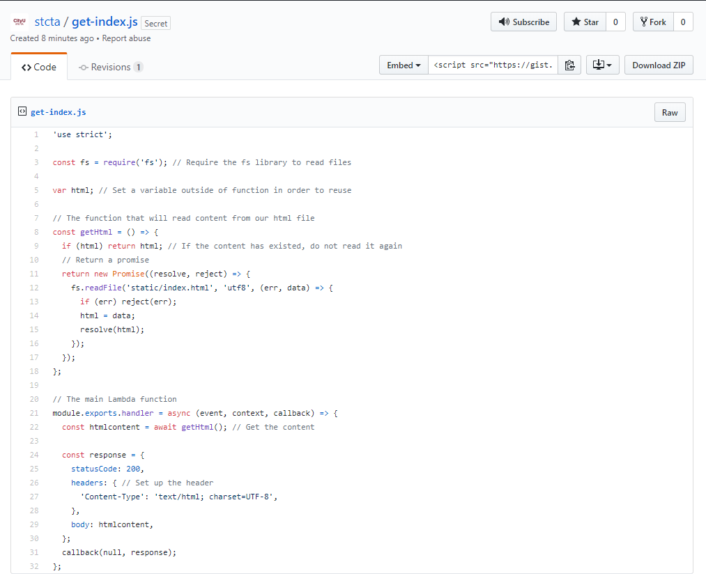

1. Replace the old content in the get-index.js with the new one and save your file.
2. Create a new folder under **the root folder** and name it to “static”

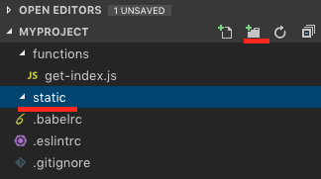

1. Create an “index.html” file in the static folder

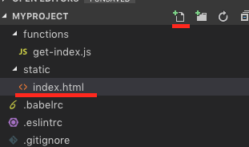 

1. Copy the content from <https://bit.ly/2wU8fIq> to the index.html file.

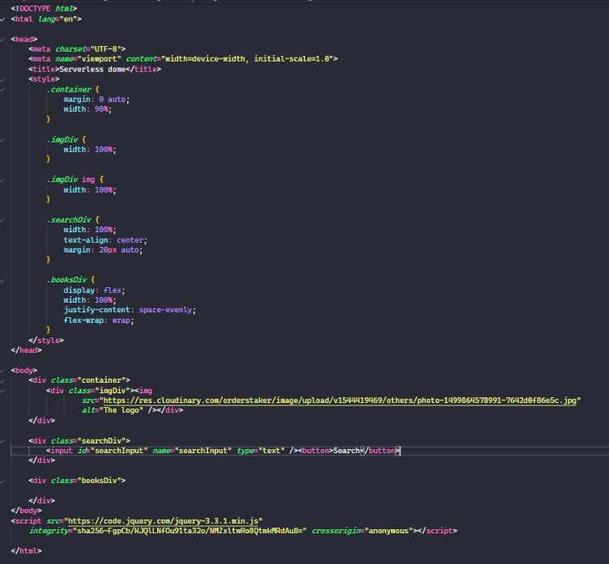

1. Open a terminal (press control and ~ keys) in VSCode and type “sls deploy” to deploy your new function. (**It may take a while based on your network speed**.)

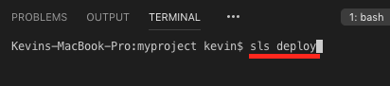 

1. Copy the URL from “endpoints” and put it in the browser to invoke it or press “ctrl+click” to follow link.  
   A screenshot of a cell phone

   Description automatically generated   
   Note: you will have different URL endpoints.   
   You can see the html content in your browser.  
     
   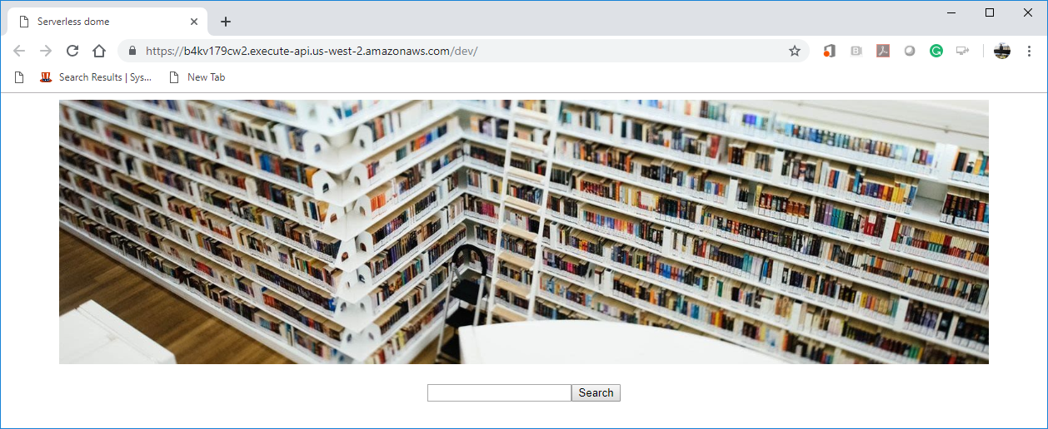

**Push your work to GitHub**

Open the terminal from the VSCode by hit the control + ~ key and type the following command:

Run the following commands to push your work to the GitHub repository:

>>> git add .

>>> git commit -m “Submission for Module 4”

>>> git push origin YOUR_BRANCH_NAME

**Note**: you should change the YOUR_BRANCH_NAME to your own branch name. It should be firstname-lastname (e.g. maria-gracia).

If you cannot remember, run the command “git status” to check